Computer Networks: Assignment #1
Wireshark Lab: Getting Started

Name: Abdullah Ayub
Roll No: BSDSF24M029

Introduction
This report documents the results of the Wireshark ”Getting Started” lab. The objective was to capture and analyze network traffic generated by visiting the UMass Gaia server. Using Wire-shark, I observed the encapsulation of data and the specific protocol fields within the HTTP and TCP layers.

Lab Questions and Answers

Question 1: Protocol Identification
Question: List the different protocols that appear in the protocol column in the unfiltered packet-listing window.
Answer: The protocols observed in the initial unfiltered capture include HTTP, TCP, TLSv1.2, DNS, and UDP.

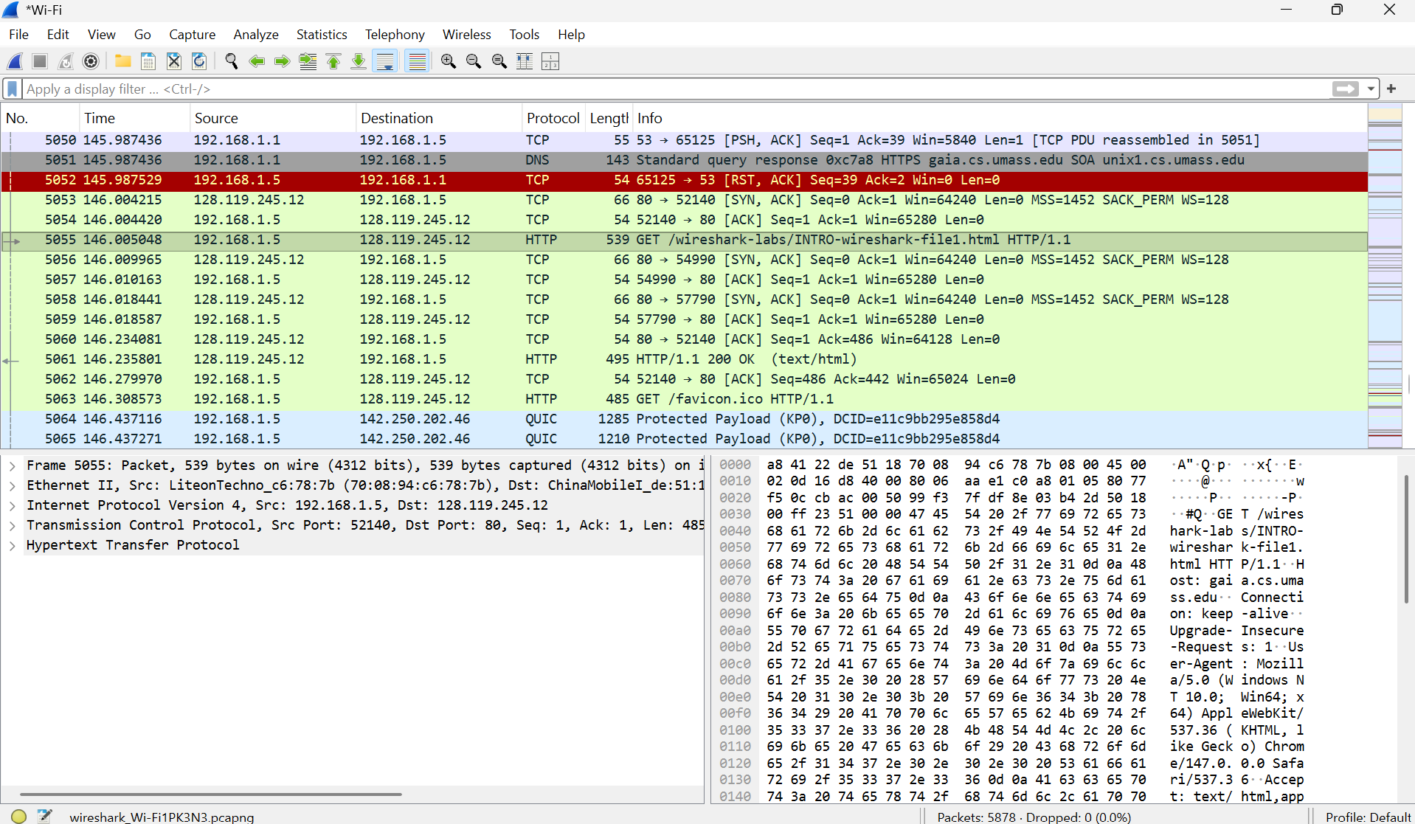

Question 2: Timing Analysis
Question: How long did it take from when the HTTP GET message was sent until the HTTP OK reply was received?
Answer: Based on the packet timestamps in the captured trace:
• Arrival Time of HTTP GET : 146.005048 seconds
• Arrival Time of HTTP OK : 146.235801 seconds
• Calculation: 146.235801 - 146.005048 = 0.230753 seconds
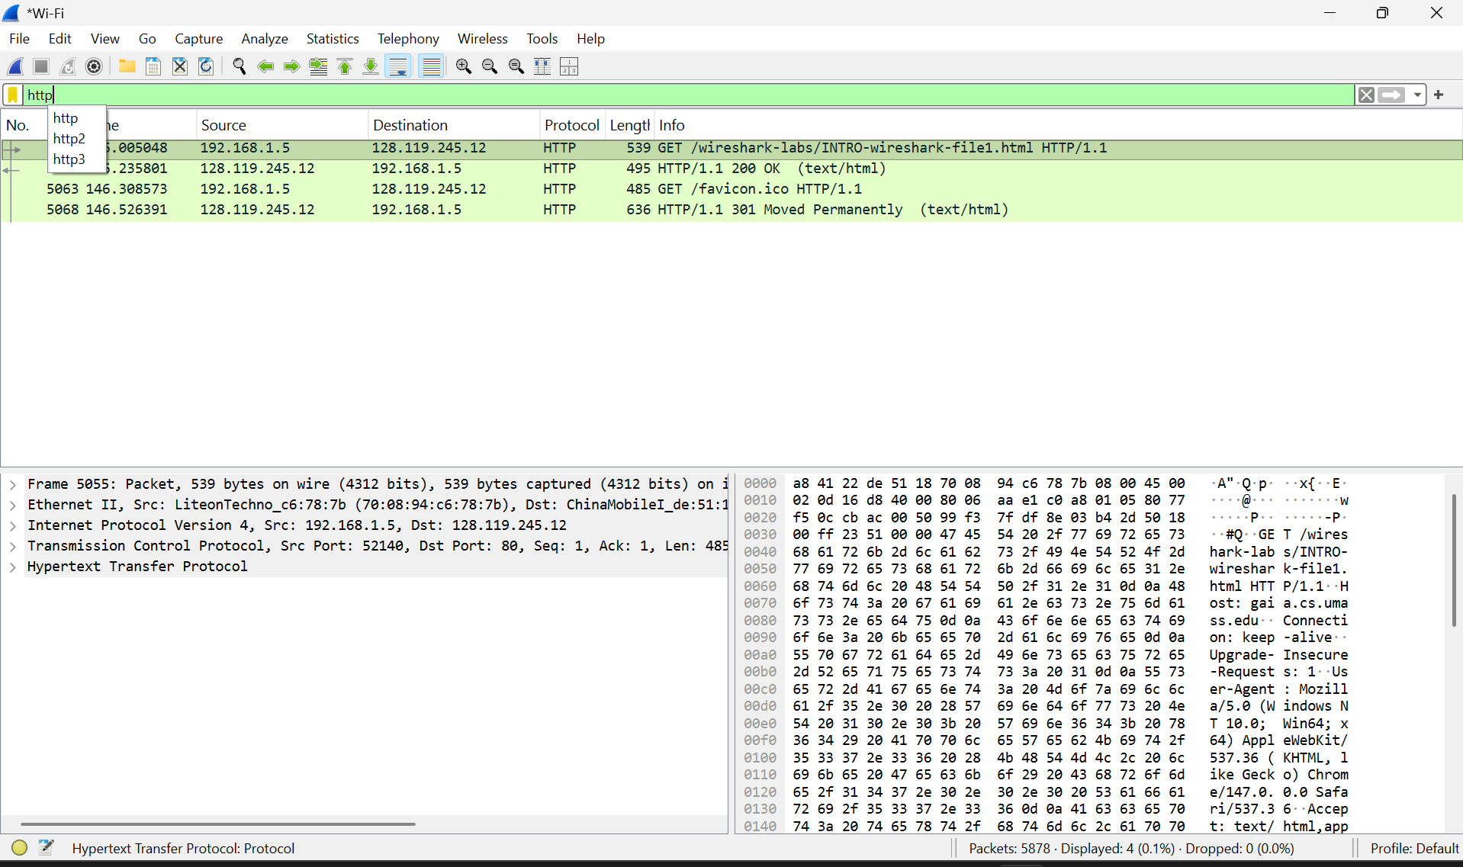

Question 3: IP Addressing
Question: What is the IP address of the gaia.cs.umass.edu server? What is the IP address of your computer?
Answer:
- Server IP (gaia.cs.umass.edu): 128.119.245.12
- My Computer IP (Source): 192.168.1.15

Question 4: Web Browser Identification
Question: What type of Web browser issued the HTTP request?
Answer: The HTTP request was issued by Chrome (as identified by the ”User-Agent” field in the application layer data).
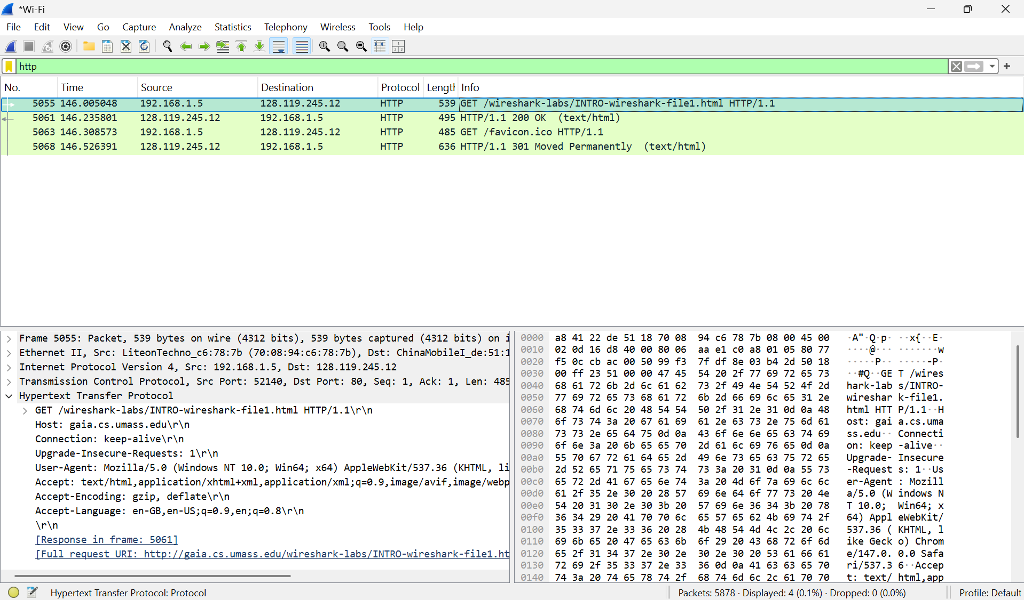

[PASTE SCREENSHOT 2 HERE]
Detailed view of the HTTP header showing the User-Agent field.

Question 5: Destination Port
Question: What is the destination port number to which this HTTP request is being sent?
Answer: The destination port number for the HTTP request is 80.
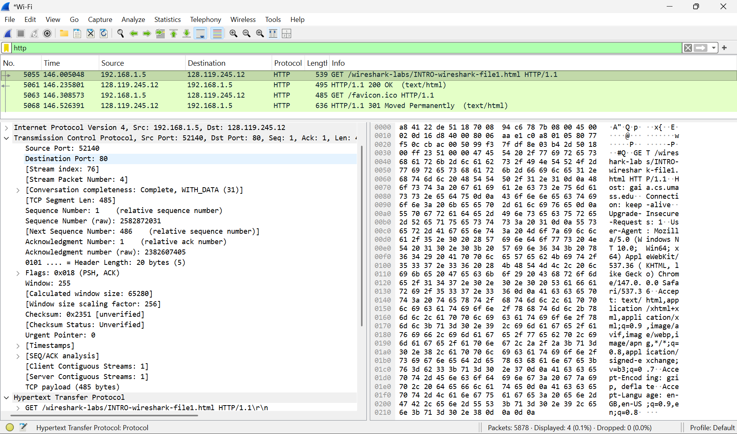

Task 6: Exported Packet Documents
The required exported files for the individual HTTP GET and HTTP OK messages have been gen-erated as separate PDF attachments as per the lab instructions.

